**DIY Composite Components**

We are going to build a component to easily mark your progress in the Talent Launch. For each succesfully completed course you can create a badge and add it to your own website/Linkedin/résumé.

The badge will have three properties. A URL for a nice image, a String for the name of the course, a Number for your grade. The badge will look like this:

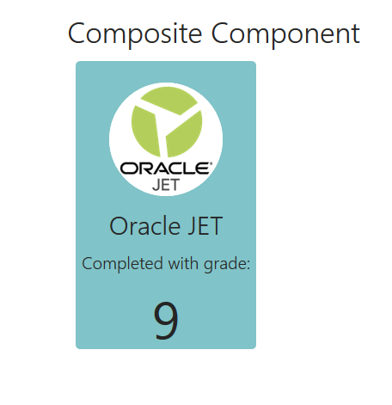

To help you with the styling we will provide a part of the css classes, feel free to change of course:

course-badge{

display : block;

width : 210px;

height: 310px;

margin : 10px;

}

course-badge .badge-face {

height : 100%;

width : 100%;

background-color : #80C3C8;

border-radius: 5px;

text-align: center;

padding-top: 25px;

}

course-badge .badge-image {

height : 130px;

width : 130px;

background-color : white;

border-radius: 50%;

}

When you are done with this Composite Component, copy the files and zip them. You can use this in your training for the Visual Builder Cloud Service.

When you have time left, try to do some of these improvements for your badge:

* Add a button to the component. (Or make the whole badge clickable) Add a property to your component that will receive a function. Link the button to the function. A user can add his own functionality to the component. Don’t show the button when no function is provided!
* Make the background color dynamic based on good your grade was. (Maybe the text color needs to change as well)